**Experiment No. 03**

* 1. **Experiment Name**

AC voltage controller circuit and DC-DC converter circuit using Simulink

* 1. **Objectives**
* To become acquainted with the Simulink platform and Simulink library
* To simulate various types of circuits using blocks from the library browser
* To design both AC voltage controller circuit and DC-DC converter circuit using Simulink
  1. **Theory**
     1. **AC voltage controller circuit**

AC Voltage Controller is a thyristor-based device which converts fixed alternating voltage directly to variable alternating voltage without a change in frequency. The working principle of AC Voltage Controller is based on either of two methods: Phase Control & Integral Cycle Control.

In the phase control method, the firing angle of the thyristor is used to manage the phase relationship between the commencement of the load current and the input supply voltage. In integral cycle control, the AC input supply is turned on for a number of integral cycles before being shut off again.

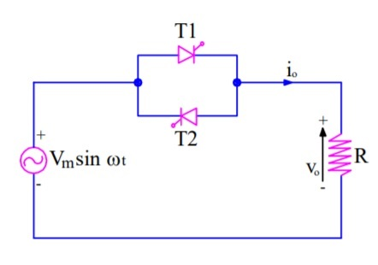

* + 1. **DC-DC converter (Boost Converter)**

A direct current (DC) to direct current (DC) converter is an electrical circuit or electromechanical device that converts a direct current (DC) source from one voltage level to another. It is a form of energy converter. Power levels range from extremely low (tiny batteries) to extremely high (high-voltage power transmission).

DC-to-DC converters are widely used for DC microgrid applications at different voltage levels. They are designed to maximize the energy harvest from photovoltaic systems and wind turbines. The entire circuit is cheaper and more efficient than a simple mains transformer circuit with the same output.

* 1. **Apparatus**
* Simulink
  1. **Simulink Block Diagram & Waveform**
* 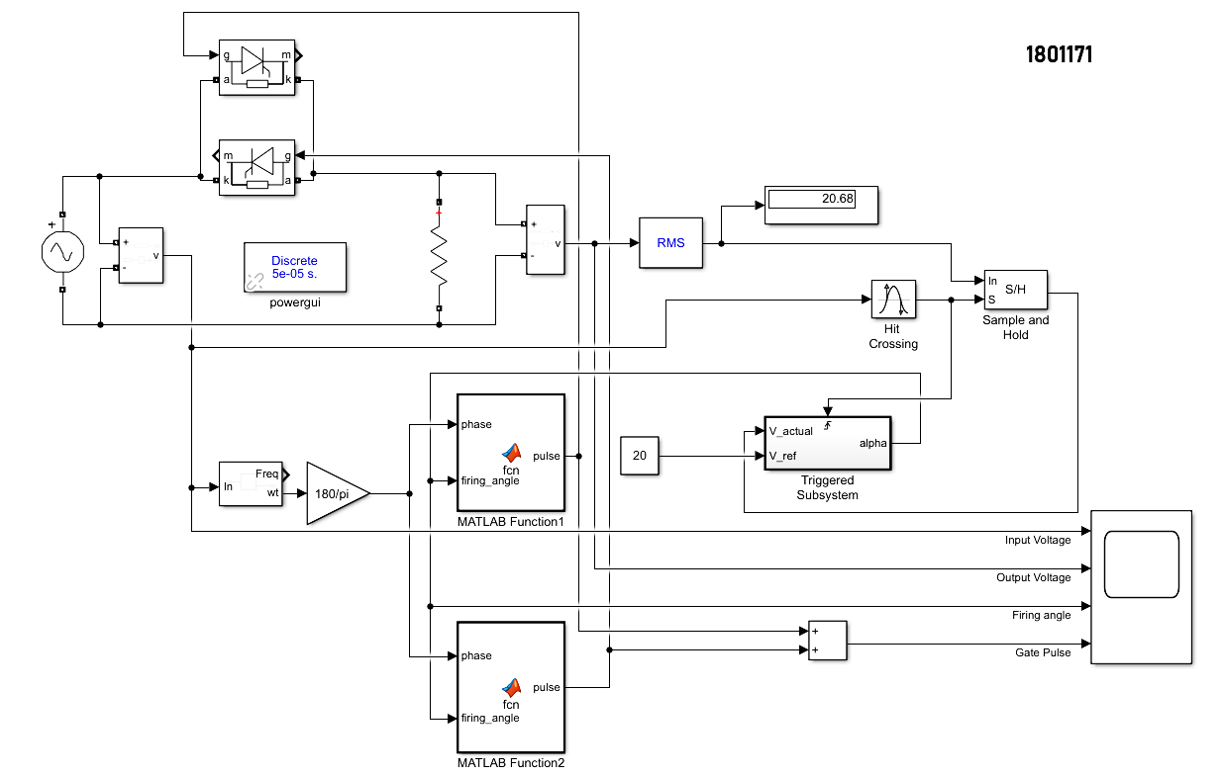**AC voltage** controller circuit

Fig. 4.1: Block diagram for AC voltage controller circuit

* **Code for triggered system**

function y = fcn(Vact,Vref)

step = 1.5;

%code_gen

persistent firing_angle

if isempty(firing_angle), firing_angle=10; end

if Vact<Vref

firing_angle = firing_angle -step;

if firing_angle<0

firing_angle =0;

end

elseif Vact>Vref

firing_angle =firing_angle+step;

if firing_angle>180

firing_angle =180;

end

else

firing_angle =firing_angle;

end

y = firing_angle;

end

* **Code for MATLAB function (positive half cycle)**

function pulse = fcn(phase,firing_angle)

pulse_width = 10;

if (phase>=firing_angle)&& phase<= min(firing_angle+pulse_width,180)

pulse =1;

else

pulse=0;

end

end

* **Code for MATLAB function (negative half cycle)**

function pulse = fcn(phase,firing_angle)

pulse_width = 10;

if (phase >=firing_angle+180)&& phase<= min(firing_angle+pulse_width+180,360)

pulse =1;

else

pulse=0;

end

end

* **Waveform**

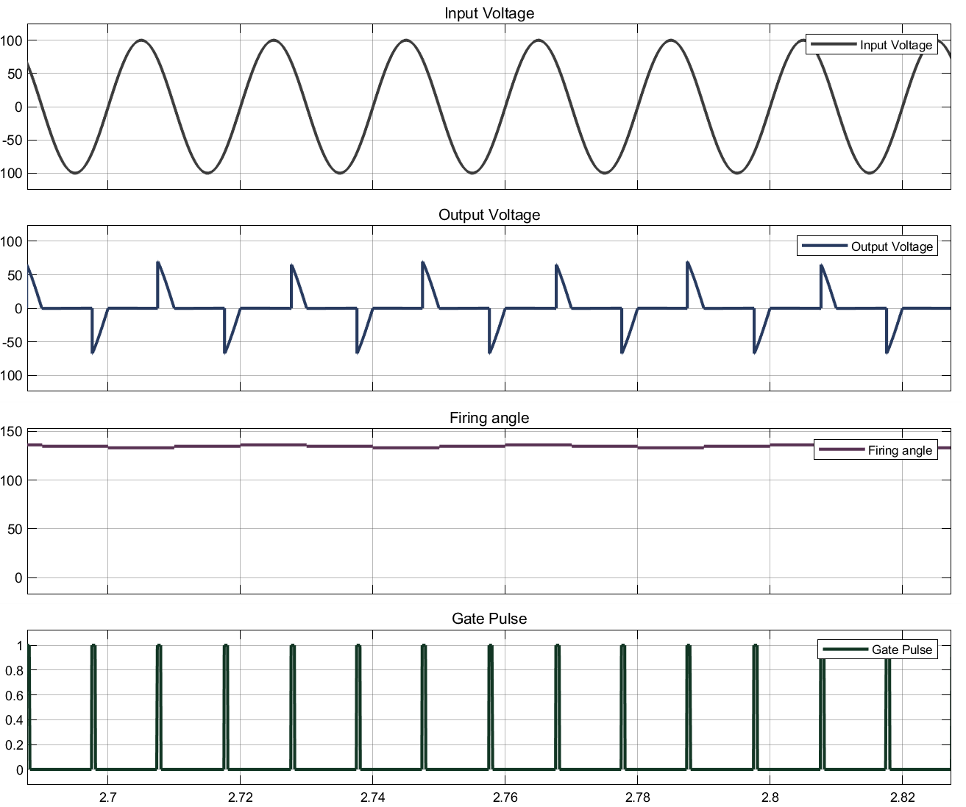

Fig. 4.2: Input, output, firing angle, and gate pulse waveform for AC voltage controller circuit

* 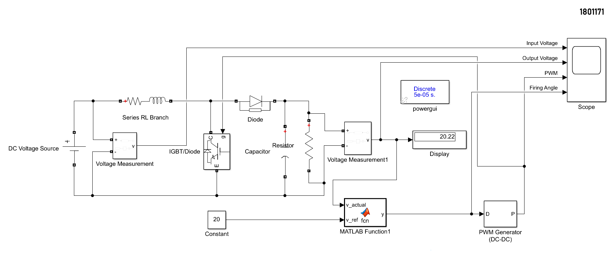**DC-DC converter (Boost Converter)**

Fig. 4.3: Block diagram for DC-DC converter (Boost Converter)

* **Code for MATLAB function**

function y = fcn(v_actual,v_ref)

delta = 0.01

persistent D

if isempty(D), D = .1; end

if v_actual < v_ref

D = D+delta;

if D>=.75

D = .75;

end

elseif v_actual > v_ref

D = D-delta;

if D<0;

D = 0;

end

else

D = D;

end

y=D;

end

* **Waveform**

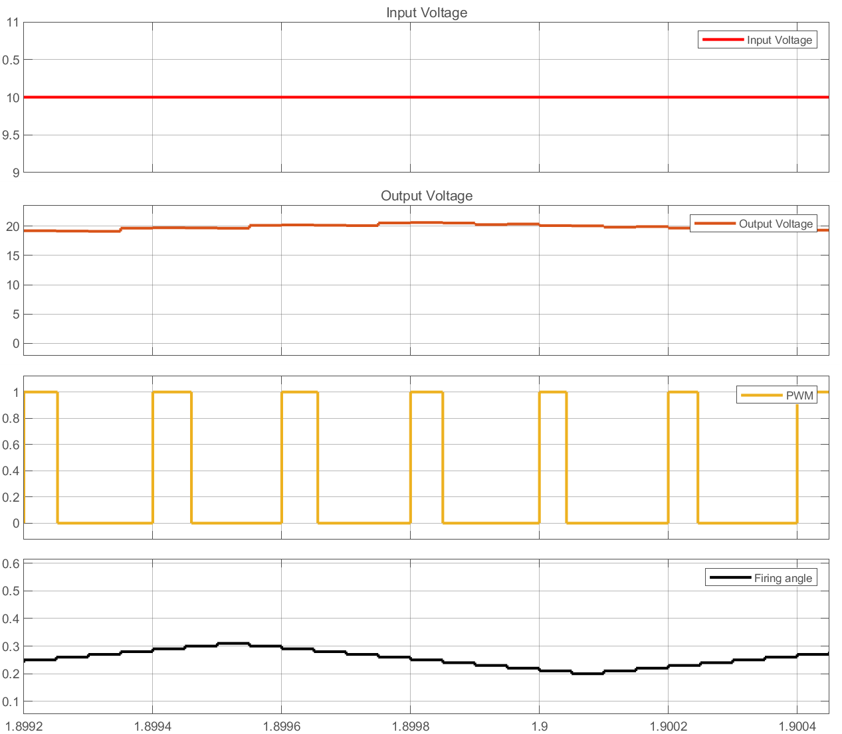

Fig. 4.4: Input, output, PWM, and firing angle waveform for DC-DC converter (Boost Converter)

* 1. **Discussion & Conclusion**

In this experiment, triggered subsystem block was used. Additionally, to decrease the amount of block components in the Simulink platform, we employed MATLAB function blocks and codes. We were able to successfully design an AC voltage regulator and a DC-DC converter (boost converter) circuit as a result of this experiment. Moreover, expected outputs were observed at scope. Thus, the experiment was a success.

* 1. **Reference**
* <https://electricalbaba.com/what-is-ac-voltage-controller-definition-working-and-application/>
* <https://en.wikipedia.org/wiki/DC-to-DC_converter>